Exploring economic wellbeing of households using indirect assessment methods:
applications for targeting social benefits and welfare economic research
By: Moaven Razavi

Abstract:
This study is a ‘proof of concept’ investigating the possibility of indirect assessment of household economic wellbeing using data mining techniques applied to large databases of household income and expenditure surveys. It assumes that economic wellbeing is a latent variable not directly quantifiable using self-reported monetary variables, yet indirectly measurable with reasonable accuracy using a set of observable household’s characteristics. Estimation of the latent variable of wealth and economic wellbeing have useful policy and research applications including its ranking ability for less costly targeting of public benefits, also certain public policy research where the alternative indicators of wealth such as household expenditure are prone to serious endigeneity problems. The study has two sections: first, it provides indirect estimates of the latent variable of wealth using linear algebra techniques followed by introducing a ranking methodology and statistical validation of the estimates and its ranking precision and power. Next, it uses the estimates of the latent variable of wealth as a consistent independent variable in a conditional probability model that would otherwise provide biased estimates due to endogeneity of household expenditure as a common proxy for household’s wellbeing. The later model investigates the determinants of risk of catastrophic healthcare payments. As estimated and statistically validated by this study the quality of the estimates for wealth is reasonably well in particular in ranking low income and lower/middle class households. When put in test in a real world public policy research application, the estimates of wealth helped us understand the association of wealth and the risk of catastrophic health expenditures.

Introduction:
The science of data mining as the foundation of ‘big data’ enterprise is by far the fastest growing frontier in statistics and econometrics field. The extraordinary growth owes to the availability of large databases across all fields of research. Business Intelligence (BI) and Genomics are only two examples of applications of data mining on massive databases of consumers’ purchasing behaviors and DNA samples databases, respectively.
These modeling techniques are all developed around the idea that there is a latent variable out there that is not revealed or otherwise easily observed, however this latent variable could be indirectly explored using linear algebra techniques applied to the covariance matrix of the observed variables in large databases. The more advanced versions of data mining techniques combine principles of linear algebra with econometric models known as Structural Equations Modeling (SEM). This later generation allows multiple latent variables to be simultaneously explored using a common set of observed variables while releasing some of the constraints of the classic models.
As a proof of concept this study is an empirical attempt to examine the possibility and applicability of data mining modeling techniques on large household income and expenditure survey (HIES) databases in order to provide an estimate for the latent variable of economic wellbeing and wealth of households assuming that self-reported monetary variables of income and expenditure within the HIES lack reliability or otherwise suffer from endogeneity in certain public policy research. Analogous to the research agenda of Business Intelligence that uses the past history of consumers’ behavior (as reported in massive transaction databases collected by credit card companies), and tries to cluster consumers in meaningful classes where each class has a certain purchasing behavior vis-à-vis certain commodity classes and uses such clustering for targeted marketing purposes and advertisement campaigns, there could be applications for public policy where governments can identify meaningful socio-economic strata for efficient targeting of social benefits. This type of research seems in particular relevant in today’s public policy agenda in Iran where the distribution of subsidies known as “هدفمندی یارانه ها” is already facing serious targeting challenges. In absence of a reliable targeting mechanism a significant portion of scarce money allocated to almost all social benefit programs would always be taken away by those households who are less eligible yet hard to identify by the government agencies.
In fact there are many incidences in social policy where identification of low income families will be of great benefit to improve the efficiency of public programs. Here is another example: Iran is moving toward a major health insurance reform; one that is characterized as a “single-payer” model and involves a consolidation of almost all of the employment-based insurance funds into what is officially considered to be Iranian National Insurance according to the latest legislations within the current 5-year development plan. There is a great deal of labor and health economics research needed to support successful implementation of such national pool, supposedly in charge of health financing for up to 80 million members in near future. The foremost provision of the current reform legislation is the one that targets needy households and provides them with insurance premium assistance so they can join the universal insurance pool and equally enjoy its protection against risk of financial loss at the time of illness.
In another front targeting of needy population helps health policy makers in implementing price discrimination policies in favor of needy households. A well-established fact in microeconomics tells us that insurance coverage is associated with moral hazard and inevitable dead-weight loss. Mitigation of the moral hazard is usually done by all sorts of co-payments, co-insurances, and deductibles as quasi market price tools; a policy recommended by economists and known as consumer cost sharing. However, consumer cost sharing always leads to efficiency-equity trade-off caused by restriction in access to healthcare services by poor and severely ill. Currently, the much fragmented health insurance industry in Iran lacks a transparent and useful targeting policy, if it follows one at all. On the other hand, at the national scale, price discrimination and exemptions in favor of poor using universal means testing are painfully expensive. Self declared income method was an option that unfortunately exhausted and failed during Ahamdinejad’s administration perhaps as of politicizing of the policy and its ill-implementation. While the new administration tries to distance from the poor legacy of the self-reporting income method for implementation of subsidy distribution “هدفمندی یارانه ها” and also targeting of its other social protection programs, indirect assessment of household economic well-being remains a viable option and it is worth investigating by economists.
This study, as a ‘proof of concept’ investigates the possibility of indirect assessment of household economic wellbeing using data mining techniques applied to annual large databases provided by HIES. It assumes that economic wellbeing is a latent variable not directly quantifiable using self-reported monetary variables, yet indirectly measurable with reasonable accuracy using a set of observable household’s characteristics as reported in various chapters of the HIES. Estimation of the latent variable of wealth and economic wellbeing helps us in ranking and classification of households similar to the concept of income deciles. Additionally, in certain public policy research where the alternative indicators of wealth such as household expenditure are prone to serious endigeneity problems, the estimates of the latent variable are among viable alternatives in addition or as alternatives to instrumental variable models. According to these two distinct applications for estimates of the latent variable of wealth this study is organized in two sections: first, it applies data mining concepts into large HIES database and provides indirect estimates of the latent variable of wealth using linear algebra techniques followed by introducing a ranking methodology and statistical validation of the estimates and its ranking precision and power. In second section the study uses the estimates of the latent variable of wealth from first section as a consistent independent variable in a conditional probability model that would otherwise provide biased estimates due to endogeneity of household expenditure as a common proxy for household’s wellbeing. The later model is in fact a research in health policy that investigates the social, demographic and economic determinants of risk of catastrophic healthcare payments. Such model is of benefit in identifying the populations at risk of impoverishment due to catastrophic healthcare payments so that they can be protected by targeted protection measures such as premium subsidy or exemptions from consumer cost sharing.

Method:
Data mining models focus on exploring of latent variables not directly observable by researchers. In this study we try to provide an estimate for the latent variable of wealth and economic wellbeing using the HIES data. Several methods have been suggested and applied to household survey data. Among the most popular ones are principle component analysis and multiple-indicator methods. Some researchers however suggest that the choice of principal components is a pragmatic one to a data constraint problem, with the underlying assumption being that household long-run wealth (or standard of living) explains the maximum variance in the asset variables (Filmer and Pritchett 2001; McKenzie 2005).
Formally, given wealth vector x (x_{i} is an observable non-monetary variable of household e.g. ownership of a house or employment in formal sector etc.) the first principal component of the observations, y, is the linear combination:

$$y=a_{1}\left(\frac{x_{1}−{\bar{x}}_{1}}{s_{1}}\right)+a_{2}\left(\frac{x_{2}−{\bar{x}}_{2}}{s_{2}}\right)+\text{.}\text{.}\text{.}+a_{p}\left(\frac{x_{p}−{\bar{x}}_{p}}{s_{p}}\right)$$

whose sample variance is greatest among all such linear combinations, subject to the restriction $a^{'}a=1$ , where $a={\left(a_{1},a_{2},\text{.}\text{.}\text{.},a_{p}\right)}^{′}$ is the vector of coefficients, and ${\bar{x}}_{k}$and s_{k} are the mean and standard deviation of variable x_{k}. The principal component score for household i with vector of assets x_{i} is then $y_{i}=\left(a^{'}\text{.}{\tilde{x}}_{i}\right)$ where ${\tilde{x}}_{i}$ is the vector of standardized variables, $\frac{\left(x_{k}−{\bar{x}}_{k}\right)}{s_{k}}$. This transformed variable has zero mean and variance λ, where λ is the largest eigenvalue of the correlation matrix of the x (McKenzie 2005).
The first principal component therefore gives an index providing maximum discrimination between households, with the observed variables which vary most across households being given larger weight. Those variables that look similar across almost all households will thus be given trivial weight in the first principal component, as they explain very little of the variation across households. That is to say that the first principal component explicitly puts more weight on observed variables that are more unequally distributed across households. Similar to Filmer and Pritchett (2001), and McKenzie (2005), the latent variable of wealth in this study will not be adjusted for household size, since the benefits of infrastructure, the quality of housing materials, and many durable assets such a private car are available at the household level, and therefore focus on inequality across households.
Once the latent variable of wealth is estimated using the principal components method, we will examine its ranking power and accuracy using statistical tests. To provide a baseline for comparison we use the household expenditure as another proxy of permanent income and hence economic wellbeing. We put the ranking of households provided by the estimated latent variable of wealth next to the ranking by HIES’s observed variable of household expenditure. The estimated latent variable of wealth as provided by the principal components method is an ordinal measure while the household expenditure is a cardinal measure that could be used for ordering and ranking as well. To compare the ranking power of our ordinal estimate and a cardinal measure we use Spearman rank correlation test which implicitly tells us how reliable are the estimates of the latent variable in ranking households. Graphical visualization of ranking are also presented to shed more light on applicability of the ranking especially for identifying low income and lower/middle class households from less eligible wealthy families.
In the second section we put our estimated wealth variable at test using real world data to estimate a conditional probability model. Nowadays achieving universal coverage for health services regardless of income and social status is by far the foremost priority of health systems around the world. The much disputed Affordable Care Act (AKA Obama Care) is one of many examples of health financing reforms around the world through which governments are trying to expand the insurance coverages to all citizens. Government of Iran is no expectation and it too has a reform agenda within its current 5-year development plan to get uninsured Iranians under insurance coverage. The universal coverage policies in general have significant provisions involving targeting of low income uninsured households and providing them with premium subsidies so they too can join the insurance pool. Researchers in health financing and universal coverage field are always interested to somehow identify the populations at highest risk of financial loss as of catastrophic expenditures. The answer to this question provides guidance to policy makers as which socio-economic strata are at highest priority to provide the premium subsides and other safety net measures. In this section we offer a conditional probability model to explore the socio-economic determinants of the risk of catastrophic payments using data from HIES 2002.
Our econometric model investigates the risk of catastrophic health expenditures controlling for a set of socio-economic characteristics of households e.g. residency status, employment status, demographics, education, insurance coverage, and income (replaced by our estimated wealth index explained earlier). As literature suggests the non-linear forms of income such as quadratic forms will be examined as well. Based on the World health Organization standards (WHO 2005), catastrophic health payments are defined as payments of 30% or higher of the household’s annual capacity to pay. Some studies have used the 40% as threshold. With the risk of catastrophic health expenditures for the household (30% threshold) as binary dependent variable, a probit regression model can be constructed as following:
Pr(Cata=1|X) = Φ(α₀ + β₀(Residency) + β₁(Demography) + β₂ (Employment) + β₃ (Age) + β₄ (Occupation) + β₅ (Education) + β₆ (Income) + β₇ (Income Sqr) + β₈ (Insurance Coverage) + ε)
It is not uncommon to use the household expenditure as an indicator of permanent income when the self-reported income lacks reliability and precision. However in this particular research question we face a serious problem rising from endogeneity of the expenditure variable. The main reason is that total expenditure includes health expenditure and the latent variable of sudden health event or accident could affect both the dependent variable (risk of catastrophic expenditure) and the independent variable of household’s total expenditure which represents the household’s income. So considering an alternative variable besides expenditure that is reasonably representing the economic wellbeing of household yet being less prone to endogeneity problem is a necessary step in catastrophic payment research.

Results:
To estimate the latent variable of wealth we chose twenty nine variables and ran the principal components model on the dataset including the 32,086 sample households in HIES 2002. The variables were chosen from different domains including demographic characteristics, household’s owned assets, employment variables, and residency status.
Technically, most of data mining models including principal components analysis begin by investigating the covariance matrix of the observed variables. In our case the dimension of the covariance matrix will be 29X29. Theoretically, as long as none of the variables can be expressed by a linear combination of others, up to 29 eigen values could be calculated for such matrix. Table 1 reports the 29 principal components, ordered by their underlying eigen values from largest to smallest, and the proportion of the variation that could be explained by each of the components. The first component (PC1) which corresponds to the largest eigen value (6.059), is a linear combination of the 29 underlying observed variables whose sample variance is greatest among all such linear combinations. In our case the linear combination suggested by the PC1 can explain 20.9 percent of the sample variation. None of the other 28 components are able to explain such large variation. The second biggest eigen value yields an eigen vector which can at most explain 8.3%, less than half of what was already captured by the first component.

Table 1. Principal components and their underlying eigen values calculated by the principal components analysis; n=32,086; number of observed variables=29
Component | Eigen value | Proportion of the variance | Cumulative proportion of the variance
Principal component 1 | 6.059 | 0.209 | 0.209
Principal component 2 | 2.413 | 0.083 | 0.292
Principal component 3 | 1.783 | 0.062 | 0.354
Principal component 4 | 1.545 | 0.053 | 0.407
Principal component 5 | 1.441 | 0.050 | 0.457
Principal component 6 | 1.217 | 0.042 | 0.499
Principal component 7 | 1.192 | 0.041 | 0.540
Principal component 8 | 1.089 | 0.038 | 0.577
Principal component 9 | 0.984 | 0.034 | 0.611
Principal component 10 | 0.923 | 0.032 | 0.643
Principal component 11 | 0.902 | 0.031 | 0.674
Principal component 12 | 0.869 | 0.030 | 0.704
Principal component 13 | 0.830 | 0.029 | 0.733
Principal component 14 | 0.736 | 0.025 | 0.758
Principal component 15 | 0.714 | 0.025 | 0.783
Principal component 16 | 0.687 | 0.024 | 0.806
Principal component 17 | 0.665 | 0.023 | 0.829
Principal component 18 | 0.595 | 0.021 | 0.850
Principal component 19 | 0.583 | 0.020 | 0.870
Principal component 20 | 0.574 | 0.020 | 0.890
Principal component 21 | 0.534 | 0.018 | 0.908
Principal component 22 | 0.532 | 0.018 | 0.927
Principal component 23 | 0.511 | 0.018 | 0.944
Principal component 24 | 0.472 | 0.016 | 0.960
Principal component 25 | 0.406 | 0.014 | 0.974
Principal component 26 | 0.297 | 0.010 | 0.985
Principal component 27 | 0.224 | 0.008 | 0.992
Principal component 28 | 0.149 | 0.005 | 0.998
Principal component 29 | 0.073 | 0.003 | 1.000
Source: Author’s estimates based on HIES 2002

In Table 2 the relative weights of the 29 variables calculated by each of the first five principal components are reported. These are corresponding to the five largest eigen values. When the first few eigen values are all large and comparable in size it is worthwhile to look into the other components as well. In our case fortunately the distance between the first and the second eigen value is big enough indicating that the first component is the only one worth considering.

Table 2. The first five principal components corresponding to the five largest eigen values and the relative weights for the 29 variables calculated by each component; n=32,086; number of variables=29
Variable | PC1 (eigen value =6.06) | PC2 (eigen value =2.43) | PC3 (eigen value =1.78) | PC4 (eigen value =1.55) | PC5 (eigen value =1.44)
Urban | 0.271 | -0.211 | -0.180 | -0.133 | -0.029
Tehran province | 0.135 | -0.328 | 0.460 | 0.071 | 0.230
Tehran urban | 0.153 | -0.334 | 0.460 | 0.043 | 0.176
# Children under 3 years | -0.018 | -0.062 | -0.121 | 0.314 | -0.012
# Seniors 60+ years | -0.079 | 0.119 | 0.210 | -0.410 | 0.030
Female | -0.061 | -0.120 | 0.012 | -0.464 | -0.105
Education score squared | 0.194 | -0.105 | 0.007 | 0.185 | -0.349
# Employed members | -0.028 | 0.265 | 0.147 | 0.443 | 0.116
Income earners (of hhold size) | -0.037 | -0.012 | 0.097 | 0.021 | -0.035
Public sector employee | 0.146 | -0.030 | -0.136 | 0.146 | -0.307
Private sector employee | -0.041 | -0.185 | -0.280 | 0.285 | 0.186
Self employed | -0.063 | 0.252 | 0.327 | 0.117 | 0.147
Unemployed | -0.006 | -0.071 | -0.065 | -0.113 | -0.021
House ownership (owner =1) | -0.037 | 0.330 | 0.197 | -0.193 | -0.026
House quality | 0.266 | -0.110 | -0.016 | 0.031 | 0.100
# Rooms | 0.197 | 0.380 | 0.058 | 0.011 | -0.009
Area (squared meter) | 0.224 | 0.374 | 0.033 | -0.020 | -0.120
Area * Urban | 0.304 | 0.010 | -0.106 | -0.145 | -0.180
Car | 0.186 | 0.084 | 0.113 | 0.103 | -0.306
Refrigerator | 0.147 | 0.128 | -0.071 | -0.051 | 0.356
Freezer | 0.244 | 0.009 | 0.143 | 0.031 | -0.216
Landline phone | 0.257 | 0.118 | -0.039 | -0.106 | 0.046
Water (sanitized, piped) | 0.150 | 0.012 | -0.137 | -0.129 | 0.324
Washing machine | 0.265 | 0.011 | 0.063 | 0.040 | -0.068
Color TV set | 0.252 | 0.086 | -0.061 | 0.110 | 0.149
Bathroom (at home, warm) | 0.277 | 0.048 | -0.104 | -0.031 | 0.221
Kitchen | 0.238 | 0.132 | -0.077 | -0.015 | 0.272
Air conditioner | 0.146 | -0.120 | 0.316 | 0.026 | -0.182
Natural gas (piped in home) | 0.250 | -0.189 | -0.094 | -0.130 | 0.044
Source: Author’s estimates based on HIES 2002

It is worth mentioning that most of the data mining models are exploratory by nature rather than being specified or constrained by theoretical considerations or otherwise cause and effect relationships. Therefore, before declaring any victory we need to examine the relative weights given to each of the 29 observed variables making sure they are also consistent with common sense about relation of the observed variables and economic wellbeing of the household. Only then can we claim that the first principal component could be considered as the estimate of latent variable of wealth. As mentioned earlier the first component assigns the weights to each of the observed variables so that the linear combination made by these weights would give every household an index that represents its wealth and living standard. The focus should be on the high variance wealth differentiators. We are inclined to use the term “high variance wealth differentiator” because we believe it better reflects the mathematical concept behind calculation of the first principal component.
In Figure 1 the 29 observed variables along with their relative weights in the first principal component are presented. The high variance wealth differentiators list includes house area (in squared meter) in urban settings (0.30), bathroom in home with warm shower (0.28), urban residency (0.27), house quality (0.27), washing machine (0.27), landline phone (0.26), color TV set (0.25), natural gas piped in home (0.25), freezer for preserving food (0.24), unshared kitchen in home (0.24), area of house (regardless of urban or rural) (0.22), number of rooms (0.20), squared of the education score (0.19), private car (0.19), residency in the urban area of Tehran province (0.15), in house sanitized piped water (0.15), employment of head of the household in public sector (0.15) and built in air condition in the residential building (0.15).
On the other side of the spectrum we have a group of high variance differentiators with negative sign. These variables with negative weights would be in fact the identifiers for the worse-off households. The list of the variance differentiators with negative sign includes number of seniors with 60+ age in household (-0.08), self-employment status of the head of household (-0.06), female gender for head (-0.06), private sector employment for head (-0.04), house ownership (-0.04), ratio of (income earners regardless of employment e.g. farm rental income) of household size (-0.03), number of children under 3 years (-0.02), and unemployment (-0.01).
As far as the quality of our proxy of wealth is concerned, we can affirm that both the high variance differentiators of the wealthy households, and the high variance differentiators of the worse-off households, are in general properly weighted. Not all assigned weights in our long list of variables are however sensible, but the high weight ones are and therefore are the leading factors in identifying the households in terms of their relative wealth. It is noteworthy mentioning that the relative weight of the variables could well change over time in particular for those amenities that might have been considered as luxury back then when the 2002 HIES was administered. However, we reemphasize that as a proof of concept the methodology used here appears to provide a sensible estimate for the latent variable of wealth.
Figure 1: Wealth indicators’ relative weight
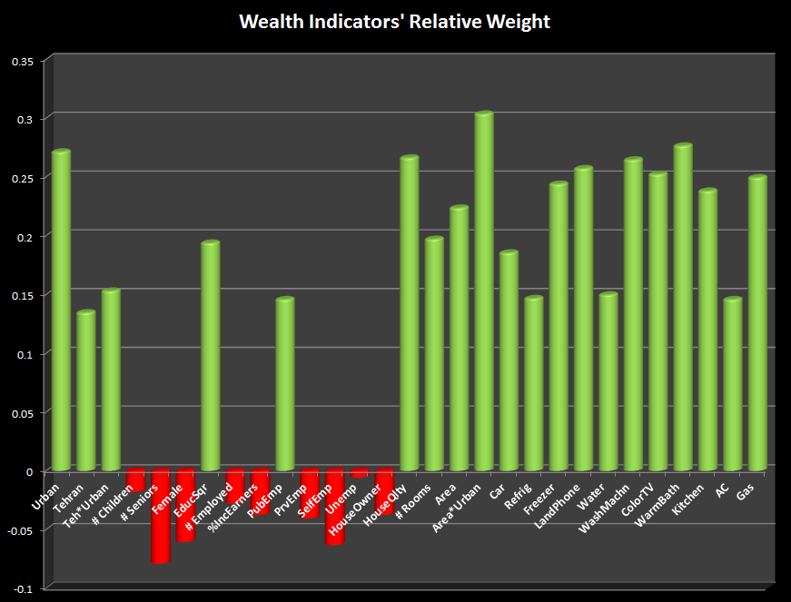
Source: Author’s estimates based on HIES 2002

The final score of the household’s wealth is calculated using the standard normalized variables. The resulting scores are standard normal themselves. Since we want to let the income effect to vary along income groups we will consider a quadratic form for the asset index variable of the household. For ease of interpretation we shifted the asset index (PC1) by the minimum amount of the PC1 and made the two new variables “PC1 shifted by 5”, and its squared, “PC1 shifted squared” to be used later in the next section’s regression analyses. Mean and standard deviation for the three variables are reported in Table 3.
Table 3. The asset index (principal component 1), the shifted positive asset index, and the shifted positive asset index squared; n=32,086
Variable | Mean | Std. Dev.
Wealth Indicator: Principal component 1 (PC1) | 0.00 | 2.46
PC1 shifted by +5 | 5.00 | 2.46
PC1 shifted squared | 31.06 | 27.40
Source: Author’s analysis based on HIES 2002

To examine the quality of our estimated wealth indicator we run some statistical tests. We begin with correlation test. If our estimated variable is a good predictor of the wealth we expect a relatively large, positive and significant correlation between the index and the household’s expenditure as reported in HIES. In order to standardize the expenditures by the household size while acknowledging the non-linear relation between benefits of economy of scale in shared expenses and the size of the household we use the concept of equivalent size recommended by the literature in health economics (WHO 2005). The equivalent size is calculated as household size raised to the power of β, where the empirical research estimate for parameter β is equal to 0.56 (WHO 2005). Ignoring the nonlinear relation means dividing the expenditure by size which implies a larger β equal to 1. The logarithm of monthly expenditure per equivalent size (in Rials, 2002 prices) is the variable used here as a baseline variable to be used for validation of our estimate of the latent variable of wealth.
The correlation between the wealth indicator and the logarithm of the expenditure variable is 0.68 and highly significant (n=32,086; p-value <0.001). We also examined the ranking power of the wealth indicator to see how reliably our estimated wealth indicator classifies households into income groups (e.g. income deciles). A Spearman’s rank correlation test between logarithm expenditure and the wealth indicator provided reasonably satisfactory results: the correlation coefficient (Spearman’s ρ) was equal to 0.66 and highly significant (n=32,086; p-value < 0.001).
Multiple graphic illustrations of the relation between the estimated wealth index and the log(exp) variable are depicted in Figure 2. In the upper graph the correlation of wealth index and expenditure are shown. The mean values of the two variables are also drawn to show how far the correlation graph passes from the cross mean points. In the lower graph the histogram distribution of log(exp) variable along with the cut-off points of the ten deciles are shown. The upper and lower graphs share the same scale and values in the horizontal axis so we can make connection between the two graphs. As it can be seen in the upper correlation graph our estimated wealth index correlates well with the log(exp) variable. While there are some distortions evident in high income household area where as the log(exp) grows the wealth index does not grow perfectly consistently and shows some fluctuations the correlation between the two is very smooth and consistent in lower middle class portions of the distribution. It is very important to get a nice and consistent correlation in the middle portion because as it is shown in the lower graph histogram that is the area where most of the households are concentrated. By mapping the red dots from the lower graph which represent the cut-off points of the deciles it can be seen that differentiation power of the estimated wealth indicator in deciles 2 through 9 is actually very good meaning that households in higher deciles are almost always having higher wealth index. In other words if households are ranked using principal component 1 that is constructed by the 19 non-monetary observed variable the result of the ranking is not any different than the ranking that is done by their log(exp) variable. The good news is that even in the decile 1 and 10 (poorest and richest households) although there are some within fluctuations due to imperfect correlation of the two variables but the cross-decile ranking is still powerful enough meaning that almost all individual in decile one have a wealth indicator less than any other decile likewise any household in decile 10 has a wealth indicator bigger than any other member in any other decile. Additionally the correlation graph in upper panel crosses the crossing point of the mean values for the two variables which is another sign for acceptable quality of ranking of our estimated wealth index. In other words by looking into the four quadrants made by the two mean point lines, every household in the right hand side (i.e. household with log(exp) greater than mean) falls in the upper side (i.e. household with wealth index greater than mean) and vice versa.
Figure 2: Precision of the indirect assessment of household income using non-monetary observable variables; n=32,086
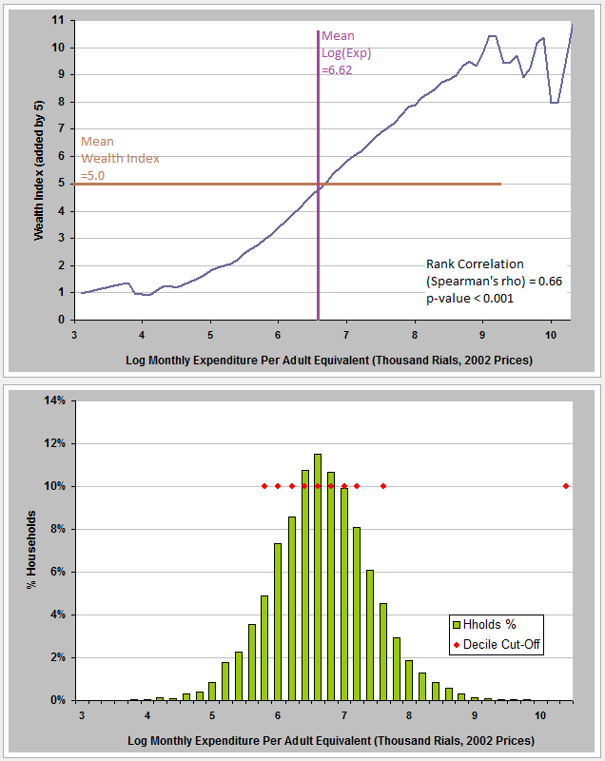
Source: Author’s estimates based on HIES 2002

Use of wealth indicator in public policy research:
Now that our estimates for the latent variable of wealth have passed multiple statistical and visual tests we feel reasonably confident about the ranking power of our wealth indicator and we can use it in the research questions that are interested in exploring income effect but the results could be biased as of endogeneity of the expenditure (as an indicator of permanent income).
Table 4 reports the estimates of the probit model coefficient and resulting marginal effects. As a reminder the dependent variable in the probit model is the risk of catastrophic payments by the household. The model suggests that employment in non-governmental jobs in general is associated with increased risk of catastrophic payments. This is perhaps due to many protections measures offered by public sector to its employees including insurance cards, supplementary insurance benefits, and also subsidized hospital inpatient services within organizations’ own facilities (Military forces, Bank Melli, Ministry of Oil, etc.) or otherwise contracted hospitals serving their employees. The risk also increases as number of young children increases as is when households live in rural areas. (The variable of number of senior members of household is also associated with higher risk but outside the statistically significant zone). Insurance obviously has a protective effect on the risk although the concept of insurance coverage as interpreted from the HIES has its own caveats. Household taken care for by middle age adults are on average better protected as the quadratic form of age variable suggests: based on probit estimates for pair of age and age-squared, the turning point for the age parabola at which the risk minimizes is estimated about 48 years.
While the socio-demographic determinates of the risk are important, the variable of interest in this study is the household income and its effect on risk as modeled using the quadratic form of estimated wealth indicator from previous sections. Using the STATA command “mfx compute, at(X = x)” as a complementary command with probit we can run a simulation for income effect. For this simulation we increase the wealth indicator from lowest to highest (jointly with wealth squared) and at each level of the wealth we calculate the average risk of catastrophic payments. STATA package does this simulation by introducing a hypothetical household for whom all of the independent variables are set at their mean or mode (for binary variables) values while only the income and its squared could vary. Results of simulation are presented in Figure 3 where the wealth indicator varies in horizontal axis (incrementally 20 levels of wealth are examined in our simulation) and the simulated risk of catastrophic payment in percentage is shown in vertical axis. This simulation clearly indicates the vulnerability of low income households when it comes to pay unpredicted and large hospital bills or otherwise significant payments for treatment of chronic diseases. For a poor household the prevalence of the risk is as high as 8 % while the risk of such payments for upper middle class drops to about 2%.
Table 4. Estimates of the probit model for risk of catastrophic expenditures; n= 32,086
Variable | Estimate | p-value | Marginal Effect
Non-public sector employee | 0.1204 | 0.026 | 0.981%
Urban | -0.0322 | 0.361 | -0.283%
Female | 0.0280 | 0.489 | 0.252%
Age | -0.0096 | 0.065 | -0.084%
AgeSqr | 0.0001 | 0.010 | 0.001%
# Children under 3 years | 0.0821 | 0.036 | 0.722%
# Seniors 60+ years | 0.0429 | 0.123 | 0.378%
Education score | 0.0041 | 0.255 | 0.036%
Insurance coverage (covered =1) | -0.1034 | 0.001 | -0.892%
Wealth Index | -0.1260 | 0.000 | -1.109%
Wealth Index Squared | 0.0065 | 0.000 | 0.057%
Intercept | -1.2728 | 0.000 | NA
Source: Author’s estimates based on HIES 2002
Wald test of overall significance of probit model estimates: χ²(11)=370.19; p-value<0.000

Figure 3: Probit model simulation for the income effect on risk of catastrophic expenditures
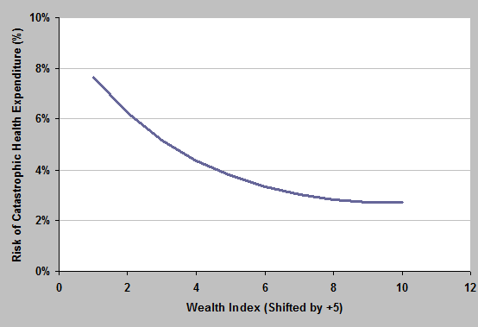
Source: Author’s estimates based on probit model applied to HIES 2002

Discussion:
The so called ‘big data’ enterprise and its underlying concepts and techniques including data mining is largely understood as a powerful tool in hand of business intelligence, marketing, and advertisement companies as well as national security agencies. In this context the negative connotation is evident and can easily overshadow the entire concept and its underlying science. Some even perceive the enterprise as a way to spy in citizens’ private life and their consumption behavior. However, it is time for the economic and public policy research to embrace the concept and the science behind it for rather goodwill research. This study as a proof of concept demonstrated how the applications of data mining could take the public policy research one step further. We acknowledge the fact that wealth and economic wellbeing of household is in fact a latent variable that is not easily and directly observed in household income and expenditure surveys, however policy makers want to know how well households with diverse socio-demographic and economic background are doing and how eligible they truly are for social benefit programs and all kinds of subsidies and exemptions. Having a reliable estimate of economic wellbeing of citizens is crucial piece of information governments wish to acquire, for better or worse. Needless to say that in today’s Iranian society everybody feels entitled to receive cash assistance paid for by the releases resources from energy subsidies for example. But can and should governments give away cash assistance so generously and indiscriminately? While targeting of social benefits using the self-reported monetary variables is seriously prone to type I and type II errors, there are perhaps other good enough measures similar to the one presented in this research that provide acceptable type I and II errors so that the social benefit programs can achieve their equity and efficiency goals simultaneously and will relatively low administrative and data collection costs. The secret here is to abandon the self-reported monetary variables in favor of those observable variables that are less prone to underreporting and hiding. We demonstrated how a set of 29 easily observable and verifiable variables that by the way have nothing to do with the household’s monetary properties can provide us with a good enough measure of the their wealth and wellbeing.
The ranking property of our estimated wealth indicator passed multiple statistical and visual tests which make it useful for classifying households into for example income deciles. However the measure could also be used in the research where other monetary indicators of income and economic status could suffer from endogeneity and in turn introduce bias into econometric model estimates.

References:

Filmer D, Pritchett LH (1999) “The Effect of Household Wealth on Educational Attainment: Evidence from 35 Countries”, Population and Development Review 25(1): 85-120.

Filmer D, Pritchett LH (2001) “Estimating Wealth Effects without Expenditure Data-Or Tears: An Application to Educational Enrollments in States of India”, Demography 38(1): 115-132.

McKenzie David J. (2005), “Measuring Inequality with Asset Indicators”, Journal of Population Economics, vol. 18, issue 2, pages 229-260

World Health Organization (WHO). 2005. Distribution of health payments and catastrophic expenditures Methodology. WHO Geneva.

